**Hybrid Cars to Look Out for in 2025**

Hybrid cars have revolutionized the motor industry amidst concerns of climate change. Combining petrol and diesel engines with an electric motor, they represent technology’s futuristic nature. Besides Tesla, brands like Mercedes, McLaren, and x have hybrid options in their portfolios debuting in Q1 of 2025.

The Tesla Model 3 makes a strong statement on luxury and modernity, judging from its design. The tires are redesigned to reduce noise, a 360-degree acoustic glass is used in the cabin to make it quiter, and a low-lying battery pack lessens rollover risk.

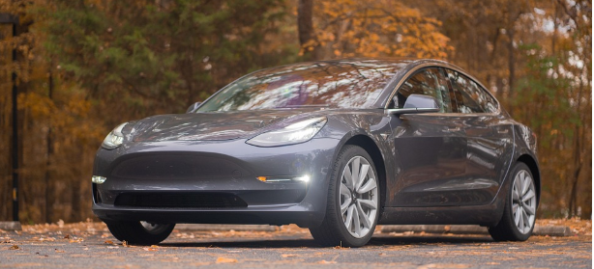

Figure 1: Tesla Model 3

The use of carbon fibre for car bodies is an impressive innovation observed in the Tesla 2025 model as well as the McLaren fleet of luxury brands. The 2025 drop in from McLaren, the Artura Spider boasts of a “high-performance hybrid powertrain” and a “new stealth badge pack” (McLaren, 2025).

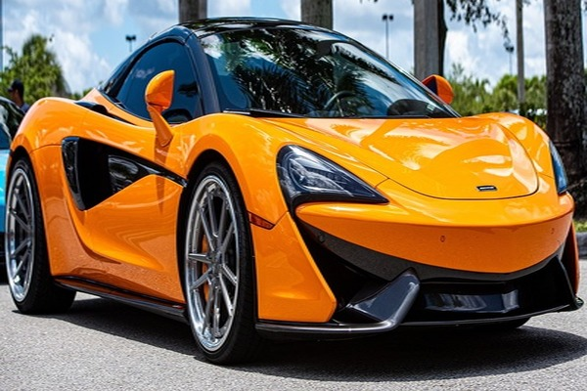

Figure 2: McLaren Artura Spider

The UK brand MG HS and Mercedes will also avail a self-charging and GLC 350 e 4MATIC SUV hybrid variations respectively in the first quarter of this year. Both brands redefine luxury with comfort-filled interiors and posh-looking exteriors. Mercedes added a transparent hood and [numerous driver assistance systems](https://media.mbusa.com/releases/release-13ade706e08532ed28da51676b05f06f-2025-glc-coupe-quick-reference-guide) to its model. Similarly, the MG HS Hybrid’s dashboard “looks like a million dollars” (Watson, 2025).

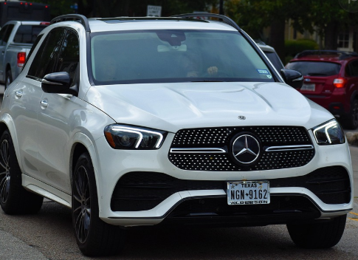

Figure 3: Mercedes-Benz GLC 350e 4MATIC SUV

Below is a brief comparison chart of the discussed hybrid cars:

|  |  |  |  |  |
| --- | --- | --- | --- | --- |
|  | Tesla Model 3 Long Range | MG HS Hybrid | Mercedes-Benz GLC 350e 4MATIC SUV | McLaren Artura Spider |
| Cost | $ 44,130 | £24,995 to £33,995 | $ 59,900 | $273,800 |
| Horsepower | 510 | 371 | 313 | 700 |
| Electric Range (in miles) | 363 | 75 | 54 | 21 |
| Acceleration | 0-100 km/h in 2.9 sec | 0-100 km/h in 6.8 sec | 0-100 km/h in 6 sec | 0-100km/h in 3 sec |
| Top Speed | 262 km/h | 210 km/h | 210 km/h | 330 km/h |
| Engine Torque | 547 lb-ft | 432 Nm Combined | Combustion engine: 236 lb-ft  Electric motor: 325lb-ft | 720 Nm combined |
| Weight (in kgs) | 1761 | 1775 | 2510 | 1457 |

References

Brauer, K. (2024, February 27). A first look at the 2025 McLaren Artura Spider, with a long list of upgrades. Forbes. <https://www.forbes.com/sites/kbrauer/2024/02/26/first-look-2025-mclaren-artura-spider-and-a-long-list-of-upgrades/>

MBUSA. (2024, November 4). *2025 Mercedes-Benz GLC 350E 4MATIC SUV quick reference guide*. MBUSA. <https://media.mbusa.com/releases/release-13ade706e08532ed28da51676b05f06f-2025-glc-coupe-quick-reference-guide>

Tesla. (2025). *Model 3*. Tesla. https://www.tesla.com/model3

McLaren. (2025). *McLaren artura spider - new hybrid convertible Supercar*. McLaren . https://cars.mclaren.com/us-en/artura-spider

Watson, M. (2025). *MG HS Review 2025: Performance & Pricing*. carwow.co.uk. https://www.carwow.co.uk/mg/hs#gref